**Assignment 18**

**Name:** Jeevan Sai Badana

**Mail:** jeevansai100@gmail.com

**Topic:** Delta lake

**Date:** 14-02-2024

**CREATE TABLE using delta in sql**

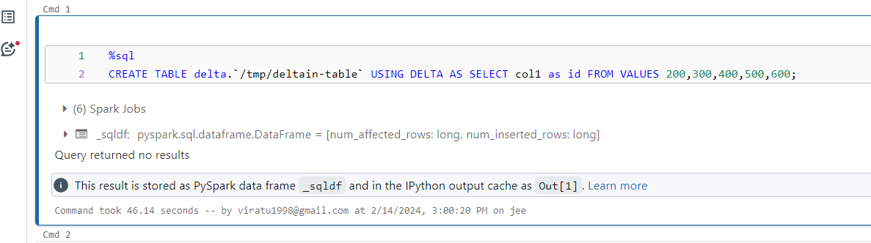

**Display the table data**

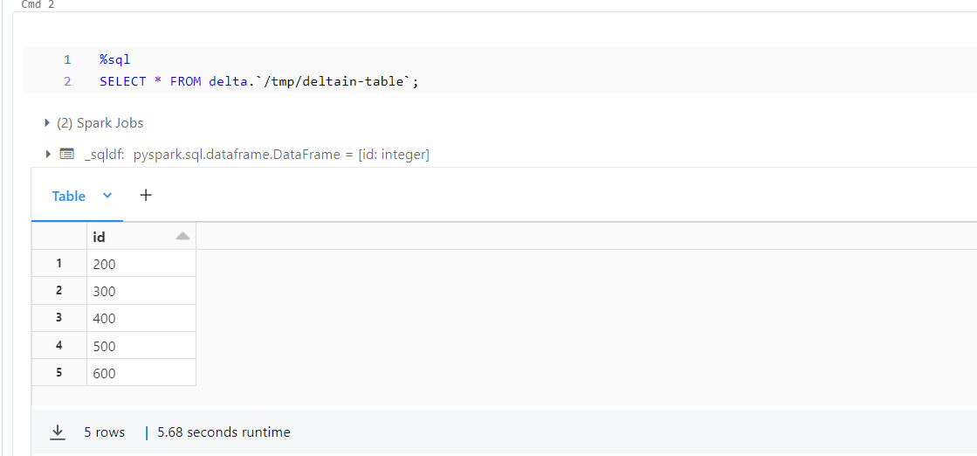

**INSERT OVERWRITE**

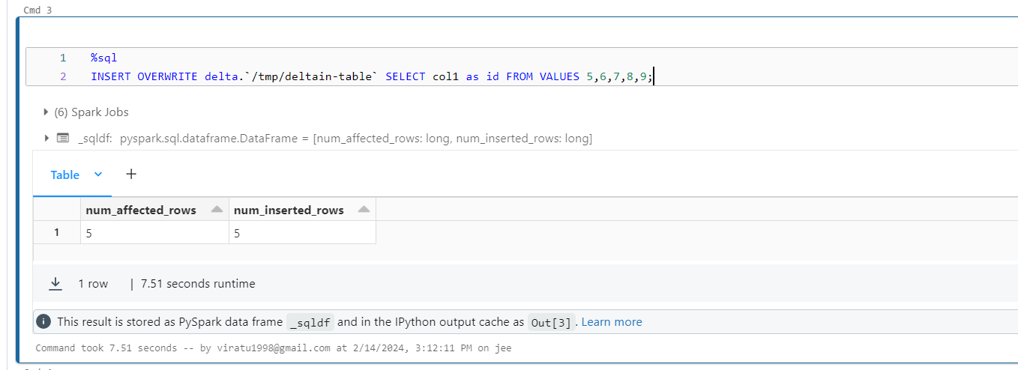

**Read older version of data**

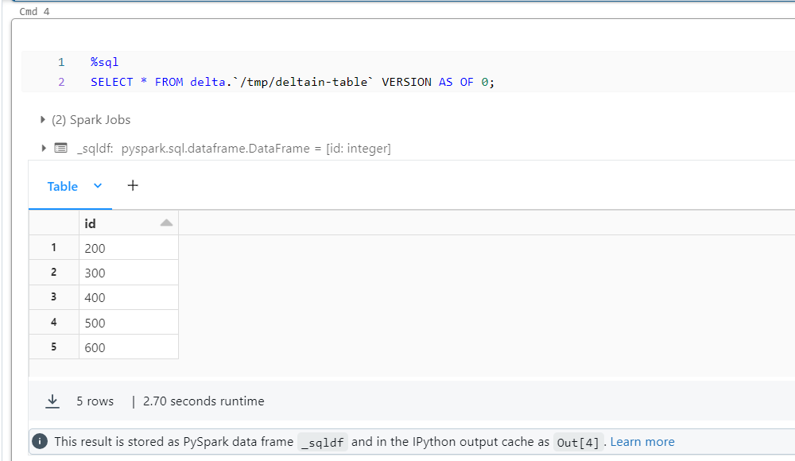

**Create table using python**

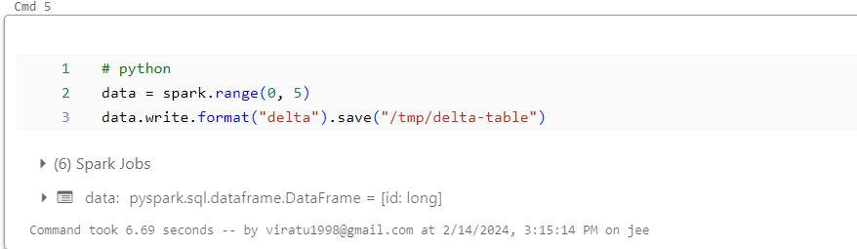

**Display the data**

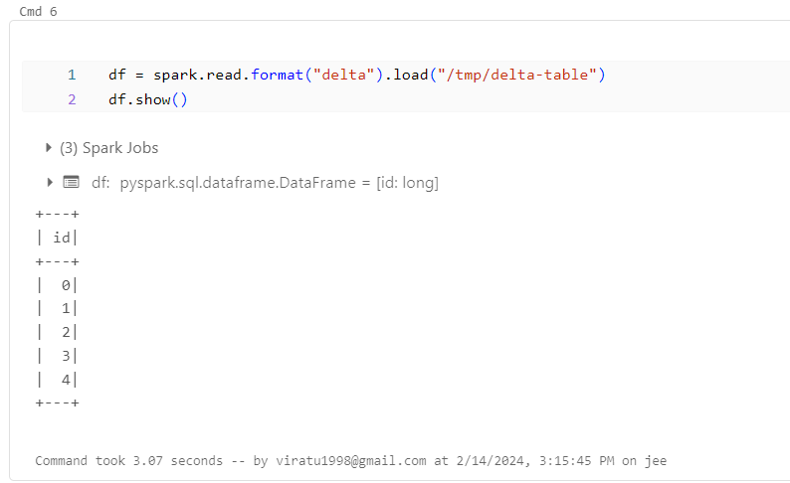

**Overwrite in python**

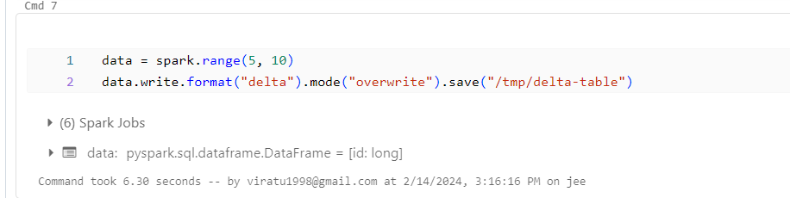

**Read older version of data in python**

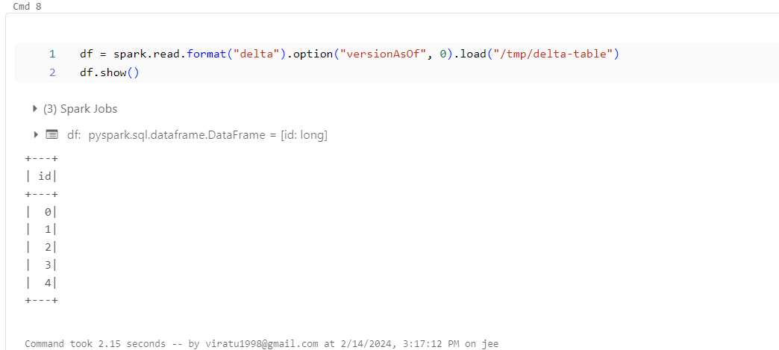

**Streaming data using python**

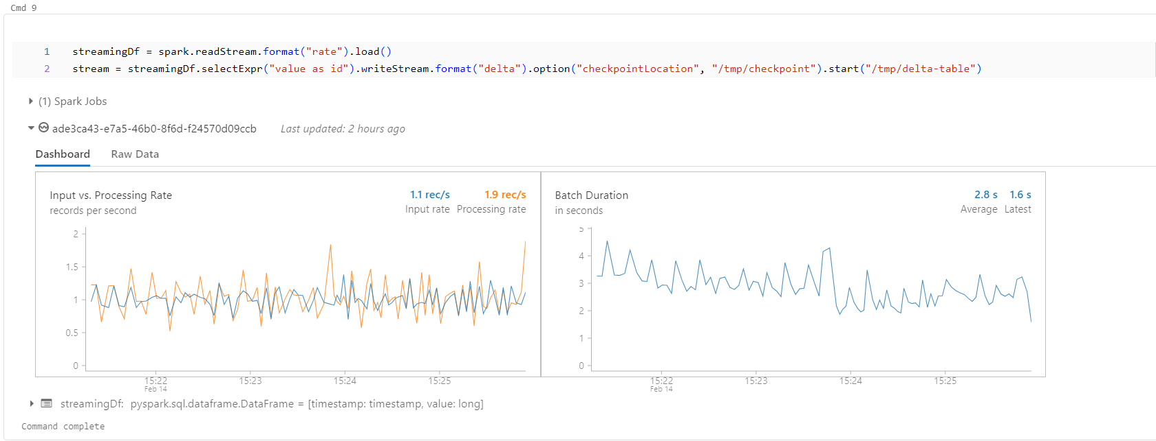

**Conditional update without using overwrite**

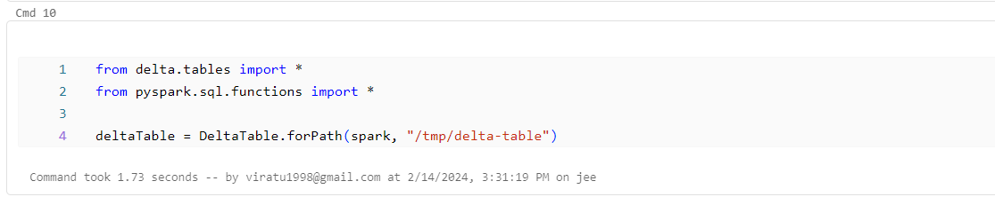

**Update every even value by adding 100 to it**

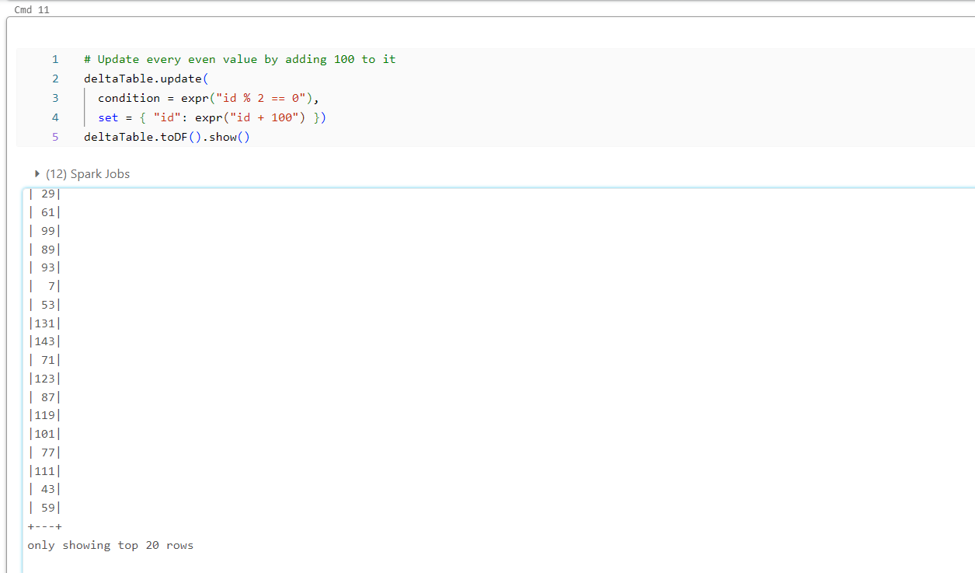

**Delete every even value**

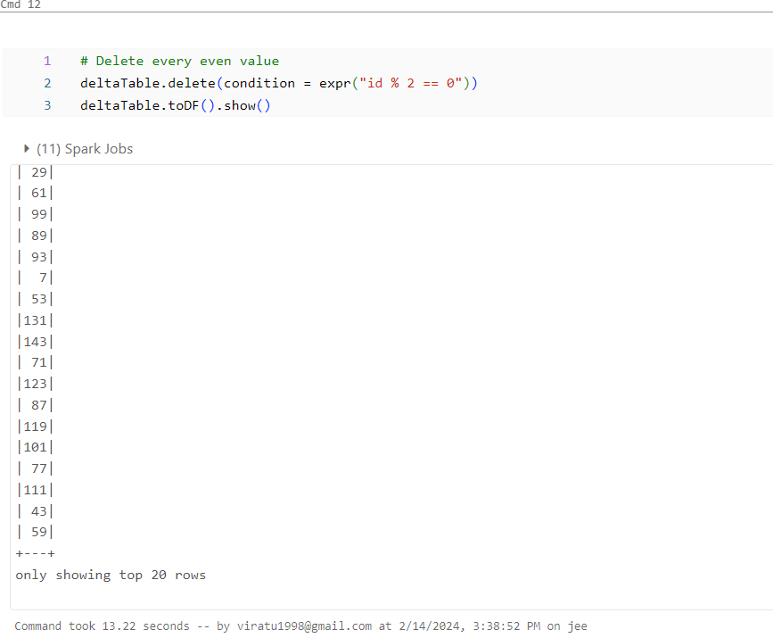

**Upsert (merge) new data**

